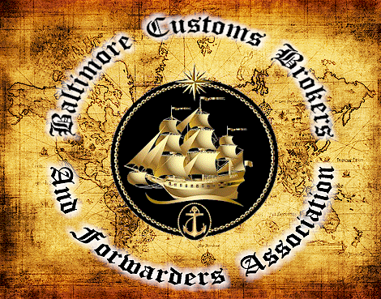

THE BALTIMORE CUSTOMS BROKERS AND FORWARDERS ASSOCIATION ANNOUNCES A HALF-DAY SEMINAR

Food Safety Modernization Act
PRESENTED BY: Ben England (bio attached)
FOUNDER & CEO, BENJAMIN L. ENGLAND & ASSOCIATES, LLC, & FDAIMPORTS.COM, LLC

How will this seminar benefit you? Find out:
- Where we are in the FSMA timeline and why FSMA is taking so long
- What you need to know about FSMA and the impact on supply chains
- What are the FSMA "Time Bombs" and how will you prepare for them
- What are the hidden costs in FSMA that will be paid by the industry and how should you prepare for these costs

DATE: September 19, 2012
LOCATION: BEST WESTERN HOTEL & CONFERENCE CENTER
5625 O’Donnell Street, Baltimore, MD 21224
TIME: 8:00 a.m. Registration, Continental Breakfast and Networking
9:00 a.m. – 12:00 p.m. Seminar
COST: $75 Member rate $100 Non-Member Rate

This event has been approved for 3 CCS or 3 CES Points

Registration required by noon September 12th. See attached registration form.
You will be charged if cancellation not received within 72 hours prior to event.
NO REFUNDS

*** Registration is a commitment to pay. ***

Baltimore Customs Brokers and Forwarders Association, Inc.
www.bcbfa.org

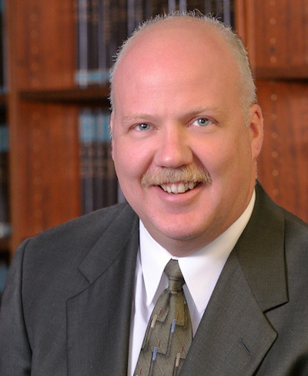
Benjamin L. England, Esq.
FOUNDER & CEO, BENJAMIN L. ENGLAND & ASSOCIATES, LLC, & FDAIMPORTS.COM, LLC

Mr. England routinely represents domestic and foreign companies of all sizes, assisting them in identifying USDA, FDA, Federal Trade Commission (FTC), Environmental Protection Agency (EPA), and state requirements. His representation enables his clients to better understand and fully comply with these federal and state requirements and thereby reduce the risk of regulatory interference with products being imported, exported or distributed in interstate commerce.
While at FDA Mr. England served as the Regulatory Counsel to the Associate Commissioner for Regulatory Affairs. Before this, he served in scientific, inspectional, compliance and criminal and civil enforcement capacities as an FDA Consumer Safety Officer (CSO), Compliance Officer (CO), a Senior Special Agent (SA) with the Office of Criminal Investigations (OCI) and an analytical regulatory microbiologist.
Most notably, during his last three years at FDA Mr. England spearheaded the agency’s integration efforts with Customs and USDA on crosscutting interagency enforcement and operational issues; served as the FDA’s point-person in managing the intersection of imports and FDA’s new bioterrorism regulations; established joint agency and industry working groups to evaluate counterfeiting and tampering risks to food and drug distribution supply chains; was the agency lead in its strategic planning efforts to reinvent the FDA’s import programs; wrote the initial statement of work and acted as program manager over the FDA’s new PREDICT, risk-based electronic entry screening system; and directed the development of the FDA’s agency-wide Risk-based Import Strategic Plan designed to improve compliance of foods, dietary supplements, drugs, medical devices, cosmetics, and biological products imported into the U.S.
Mr. England received many distinguished service awards from the Department of Health and Human Services and FDA during his 17-years of public service.
Education
Mr. England received his Juris Doctor degree, summa cum laude, from the University of Miami, School of Law where he was a member of the Order of the Coif and the University of Miami Law Review. He received his Bachelor of Arts degree in biological sciences from the University of Maryland.

FSMA Seminar Registration Form

Wednesday, September 19, 2012
8:00 a.m. – 12:00 p.m.
Location: Best Western Hotel & Conference Center
5625 O'Donnell St
Baltimore, MD 21224-4630
(410) 633-9500

Registration must be received by noon September 12, 2012

Cost $75 Per Member $100 per Non-Member – make check payable to BCBFA

Name: ____________________________________________________________

Company Name: ____________________________________________________

Address: __________________________________________________________

__________________________________________________________________

Phone: ____________________________________________________________

Fax: ______________________________________________________________

Email: ____________________________________________________________

CCS/CES# if applicable __________________________________________________

:
To complete registration, fax or email form and copy of check to 410-412-7326 (judy.zambotti-wall@kuehne-nagel.com) Attn: BCBFA c/o Judy Zambotti-Wall. Email will be sent confirming registration. Please send check to BCBFA c/o Pride International, Inc., 2200 Broening Highway Suite 230, Baltimore, Maryland 21224
Cancellations must be received 72 hours prior to event or you will be invoiced the full price.
www.bcbfa.org

